**USER GUIDE FOR LIBRARIAN SYSTEM USERS**

The application provides the following functionalities:

1. Book Search based on ISBN, AUTHOR and TITLE of the book
2. To check out the books to a card holder
3. To check in the book loans of various card holders
4. To create a new card holder (borrower) in the library.
5. To update the fines for the books.

**Library:**

* When the application is launched it looks as the following:
* It has tabs for implementation of the above functionalities.
* Library is the home page containing different buttons.
* On clicking the button it takes to the corresponding tab.

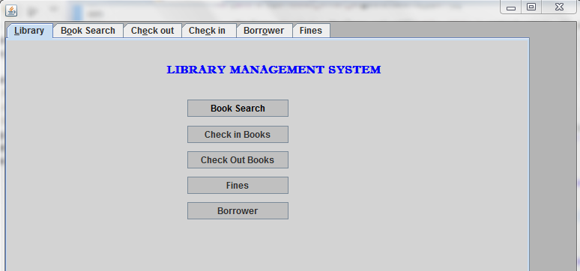

**Book Search:**

* The book search tab is as shown below. It contains text fields for isbn, title, author of the book.
* The user(librarian) is provided with the capability to search for a book by its name, title and/or isbn.
* The user has the option to check for the availability of the copies and then proceed to the checkout based on his interest.
* The following figure shows the output for book search based on the isbn =”0001047973”.

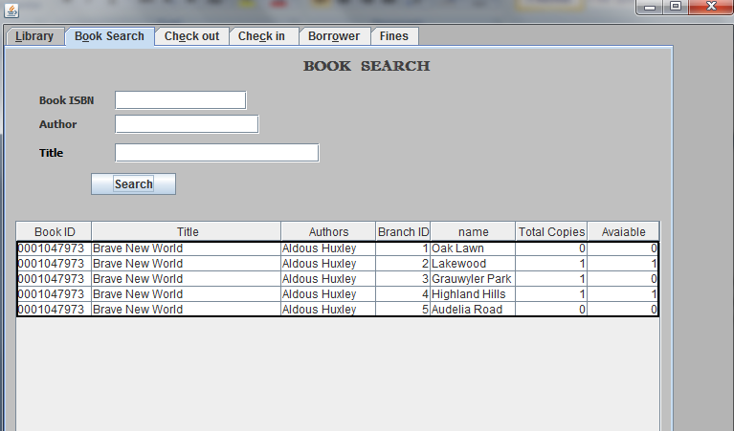

**Check Out:**

* The user can checkout the books based on the availability shown after the search.
* The user is allowed to checkout a maximum of 3 books. If the borrow limit reaches 3, then the user needs to return the books that he checked out earlier and proceed for a new checkout.
* If the branch don’t have the copies available for a specific search, then the user is not allowed to checkout that book.

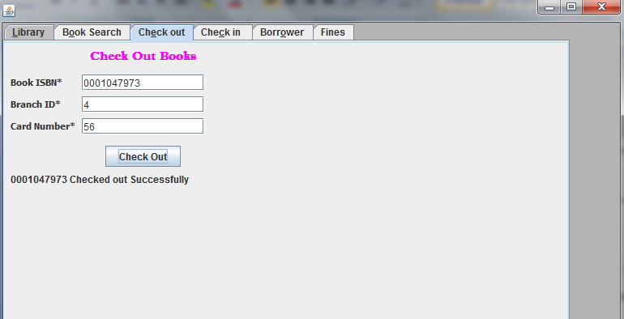

**Check In:**

* The user can check in the books.
* He can get the books based on card number or isbn or borrower name . (Get Books button)
* The user has to select one book at a time to check in it.

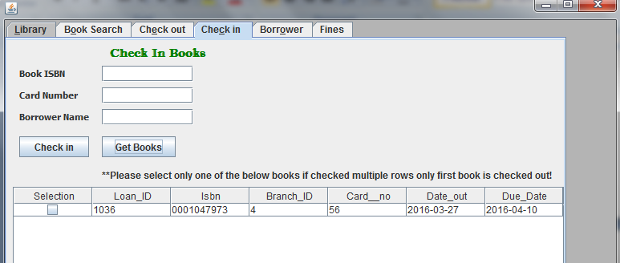

After Checking in: (Check In button)

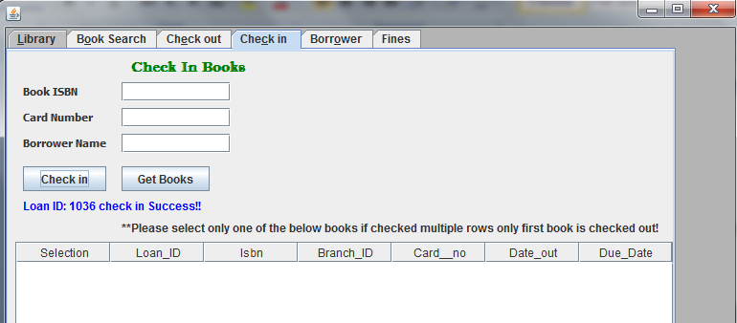

**Creating new borrower**

* A new borrower can be created by providing the details like name, ssn, address etc.
* A new card number will be generated when a new borrower is registered successfully.
* Once a borrower is registered, he will not be allowed to register again in the system.

On clicking Create Borrower button:

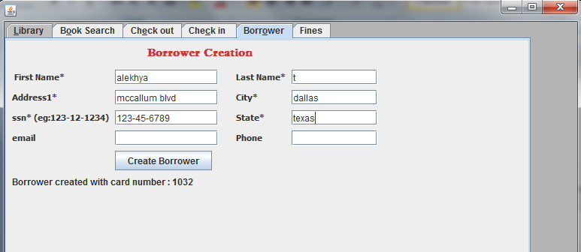

As shown above a new borrower is created with a new card number.

**Fines:**

* In the fines tab the user can pay the fine of the borrower if he has any.
* Update fines is used to automatically update the fines of every loan id. Before checking any fines of the borrower once click the update fines so that the fines remain updated till date.
* The user can get the details of the fines by providing the loan id. The user can also get the estimated fine till date if the book is not returned.
* The user cannot pay the fine without checking in the book.
* Update paid is used to updated the laon id if the fine is paid or not.

